EDU 610- Final Research Paper
Ni’Aisha Banks
Examining Alignment Between Policy and Practice of Restorative Discipline for Students with Disabilities in DCPS
April 24, 2026

Abstract
This study examines whether discipline outcomes for students with disabilities in DC Public Schools (DCPS) reflect the district’s commitment to restorative practices. Using publicly available data from the DC School Report Card and the Office of the State Superintendent of Education (OSSE), the analysis focuses on out-of-school suspension rates from the 2022–2023 through 2024–2025 school years. A descriptive and comparative approach is used to examine differences between students with disabilities and the overall student population. Findings show that students with disabilities consistently experience higher suspension rates, with disparities persisting over time and showing limited reduction. These patterns suggest that, despite the presence of restorative discipline policies, outcomes do not fully align with intended goals of reducing exclusionary discipline and improving equity. The study does not make causal claims, but instead highlights patterns that point to a potential gap between policy and practice. Implications include the need for stronger implementation, increased staff training, and improved accountability systems to ensure that restorative practices are applied consistently and effectively.
Introduction and Literature Review
School discipline plays a critical role in shaping student outcomes, particularly for students with disabilities. Despite legal protections under the Individuals with Disabilities Education Act (IDEA) and Section 504, students with disabilities continue to experience exclusionary discipline at disproportionately high rates. National data shows that while students with disabilities represent a smaller proportion of the student population, they account for a significantly higher share of suspensions (U.S. Department of Education, Office for Civil Rights [OCR], 2021). This raises an important question about whether current discipline policies are being implemented in ways that support equity. In response to these disparities, many school districts, including DC Public Schools (DCPS), have adopted restorative practices. These approaches aim to reduce exclusionary discipline by focusing on relationship-building, accountability, and addressing the root causes of behavior.
Research suggests that when implemented with fidelity, restorative practices can reduce suspensions and improve school climate (Gregory et al., 2016; Fronius et al., 2019). However, studies also emphasize that effectiveness depends heavily on consistent implementation. At the same time, research on discipline disparities continues to show that inequities persist across student groups, including students with disabilities. This suggests that policy adoption alone may not be sufficient to change outcomes. Instead, there may be a gap between policy intentions and how discipline is applied in practice. This study builds on that literature by examining whether discipline outcomes in DCPS reflect the goals of restorative practices.
Research has consistently shown that exclusionary discipline practices, such as suspensions and expulsions, are associated with negative academic and social outcomes for students. These practices increase the likelihood of disengagement from school and contribute to broader patterns of inequity (Skiba, Arredondo, & Williams, 2014). For students with disabilities, these consequences are particularly significant, as disciplinary removal can interrupt access to specialized supports and services that are critical to their educational progress. Restorative practices offer an alternative approach by focusing on repairing harm, strengthening relationships, and addressing the underlying causes of behavior rather than relying on punishment alone. Studies have found that schools implementing restorative practices with fidelity experience improvements in school climate and reductions in disciplinary disparities (Gregory, Clawson, Davis, & Gerewitz, 2016). However, research also emphasizes that the effectiveness of these approaches depends heavily on consistent implementation and system-wide support (Fixsen, Naoom, Blase, Friedman, & Wallace, 2005).
In addition to restorative practices, trauma-informed approaches have also gained attention as a way to better understand student behavior. These approaches recognize that behavior may be a response to underlying experiences and emphasize supportive interventions rather than punitive responses (National Center on Safe Supportive Learning Environments, n.d.). Despite the availability of these evidence-based approaches, disparities in discipline outcomes persist, suggesting that the issue may not be the absence of policy, but the consistency with which it is applied in practice.
Research Question
This study examines the following research question:
To what extent do discipline patterns for students with disabilities in DC Public Schools reflect the district’s commitment to restorative practices?
Rather than assessing causal impacts, this study focuses on whether observable discipline outcomes align with the intended goals of restorative discipline, particularly in reducing exclusionary practices and improving equity. Based on existing research, it is expected that if restorative practices are being implemented effectively, suspension rates would decrease overall and disparities between student groups would be reduced. However, given persistent findings in the literature, it is anticipated that students with disabilities will continue to experience higher suspension rates.
Setting and Context
This study focuses on DC Public Schools (DCPS), an urban school district that has adopted restorative practices as part of its discipline framework. DCPS promotes a “Safe and Positive Schools” approach, which emphasizes reducing suspensions and improving equitable discipline outcomes. This setting is particularly relevant because it provides a context in which restorative policies are formally in place, allowing for examination of whether outcomes reflect those policy goals.
Data Sources and Sample
This study uses publicly available data from the DC School Report Card and the Office of the State Superintendent of Education (OSSE). The sample includes DC public schools with available discipline data from the 2022–2023 through 2024–2025 school years. The unit of analysis for this study is the school level, as discipline data are reported in aggregated form. The primary dependent variable is the out-of-school suspension rate. The key comparison variable is student subgroup, specifically students with disabilities (SWD) compared to the overall student population. Because the dataset reports suspension rates directly for both subgroups and the overall population, no additional calculations were required. Suspension rates are reported as the percentage of students within each group who received at least one suspension during the school year.
Analytic Method
This study uses a descriptive and comparative analytic approach. Suspension rates for students with disabilities are compared to rates for the overall student population across multiple years. Trends are examined to identify patterns in discipline outcomes over time. A descriptive approach is appropriate because the dataset does not include direct measures of restorative practice implementation. As a result, the analysis focuses on identifying patterns and disparities, rather than testing causal relationships. Data was reviewed and organized using Google Sheets spreadsheet and the DC Report Card to compare rates across years and student groups. The analysis relies on publicly reported data, and no additional handling of missing data was required.
Findings
The findings show that students with disabilities consistently experience higher out-of-school suspension rates compared to the overall student population. In 2022–2023, the suspension rate for all students was 5.8%, compared to 9.1% for students with disabilities. In 2023–2024, the rate remained 5.8% for all students and 9.0% for students with disabilities. In 2024–2025, the rate for all students remained at 5.8%, while the rate for students with disabilities decreased slightly to 8.7%. While there is a slight decline in suspension rates for students with disabilities over time, the disparity between groups remains consistent at approximately 3 percentage points. This difference is not marginal and indicates a persistent and meaningful gap in discipline outcomes.
As shown in Figure 1, suspension rates for students with disabilities remain consistently higher than those of the overall student population across all three years. These patterns suggest that, despite the presence of restorative discipline policies, exclusionary discipline continues to disproportionately affect students with disabilities.
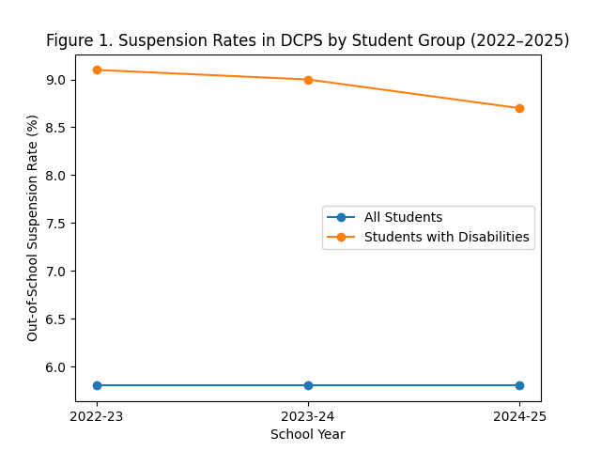

In addition to out-of-school suspensions, in-school suspension rates further illustrate this pattern. As shown in Figure 2, in-school suspension rates are consistently lower than out-of-school suspension rates for both groups. However, students with disabilities continue to experience higher in-school suspension rates compared to the overall student population. In the 2022-2023 school year, the in-school suspension rate was approximately 1.7% for all students and 2.6% for students with disabilities. In 2023-2024, the rates were approximately 1.3% for all students and 2.0% for students with disabilities. In 2024-2025, the rate for all students was approximately 1.4%, while the rate for students with disabilities increased to approximately 2.1% (OSSE, 2025). While in-school suspensions are less severe, the persistence of disparities across both types of discipline suggests that inequities are not limited to out-of-school suspensions alone.
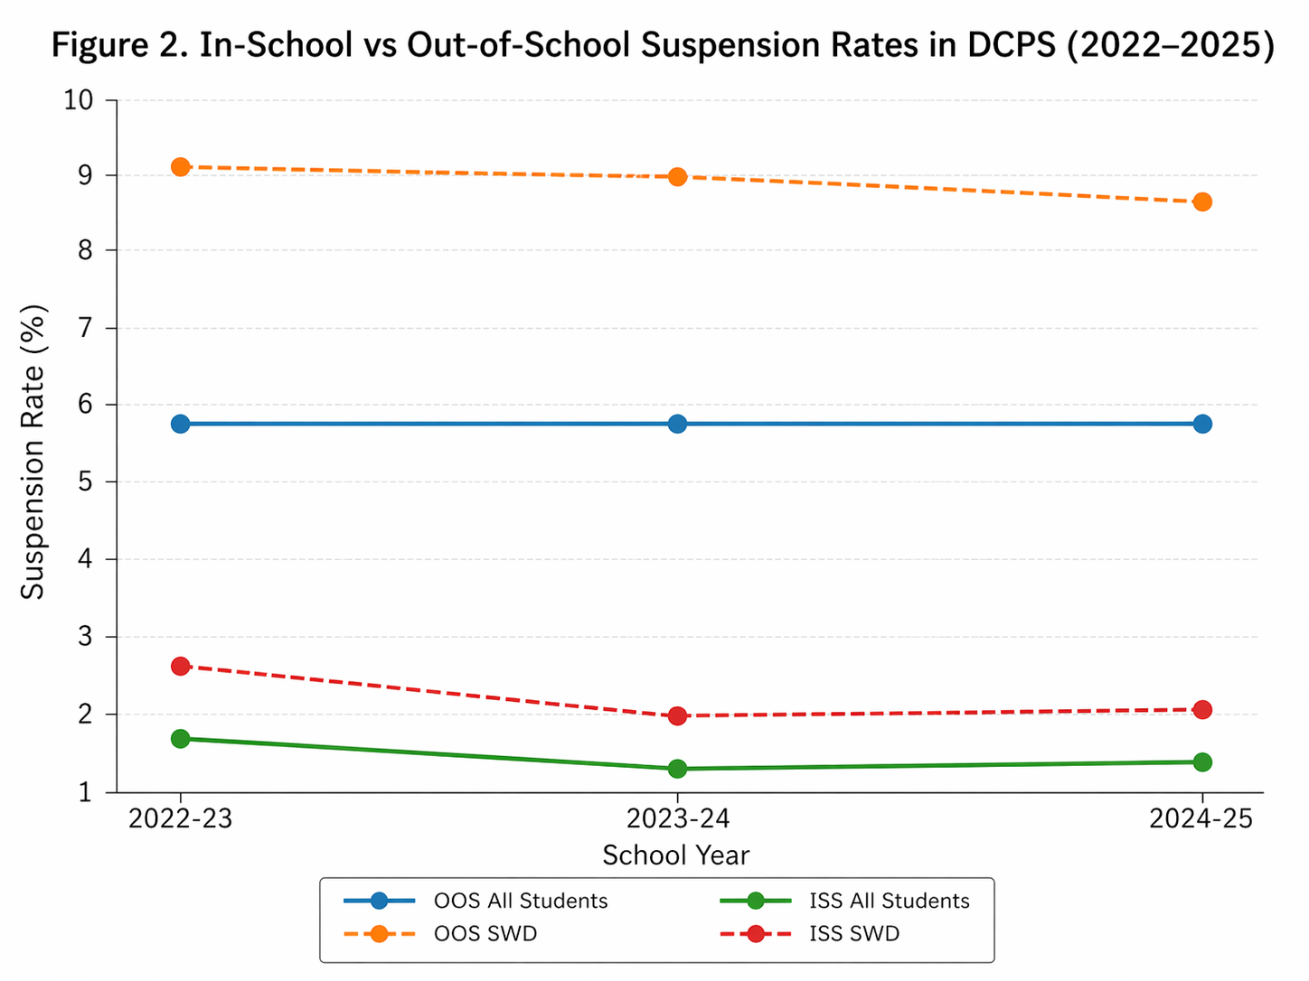

Limitations
This study has several limitations. First, it relies on publicly available, aggregated data, which does not include direct measures of restorative practice implementation. As a result, the study cannot determine whether restorative practices are being used or how effectively they are applied. Second, the analysis is descriptive and does not establish causal relationships. Other factors, such as differences in school resources, staff training, or student demographics, may influence discipline outcomes. Finally, because the study focuses on DC Public Schools, the findings may not be generalizable to other districts with different policies or contexts.
Another limitation of this study is that it does not account for variation across individual schools within the district. Differences in school leadership, staff training, and implementation practices may influence discipline outcomes in ways that are not captured by district-level data. Additionally, the study does not include qualitative data, such as perspectives from students, families, or educators, which could provide deeper insight into how discipline policies are experienced in practice. Future research that incorporates both quantitative and qualitative data could offer a more comprehensive understanding of how restorative practices are implemented and where gaps may exist.
Discussion and Implications
The findings suggest that there may be a gap between restorative discipline policy and actual outcomes in practice. While restorative practices are intended to reduce exclusionary discipline and improve equity (Gregory et al., 2016), the persistence of higher suspension rates for students with disabilities indicates that these goals are not yet fully realized. This pattern is consistent with broader research, which shows that policy adoption alone does not guarantee changes in outcomes without strong implementation structures in place (Fixsen et al., 2005). One possible explanation for this gap is the inconsistency in how restorative practices are implemented across schools. While policies may outline expectations, schools vary in their capacity, training, and resources to carry them out effectively. Differences in staff training, leadership priorities, and school climate can all influence how discipline policies are applied in practice. As a result, students may experience discipline differently depending on the school context, even within the same district.
Additionally, discipline disparities for students with disabilities may reflect broader systemic challenges related to how behavioral supports are implemented. Students with disabilities often require individualized interventions, and when those supports are not consistently provided, behavioral issues may be addressed through discipline rather than intervention. This reinforces patterns of exclusion rather than addressing underlying needs.
This has important implications for policy and practice. It suggests a need for:
- stronger and more consistent implementation of restorative practices
- increased staff training and support
- improved accountability mechanisms
- greater focus on equity in discipline outcomes
Overall, this study highlights that the presence of policy alone is not sufficient to produce change. Effective implementation is critical to ensuring that restorative practices achieve their intended impact.
AI Declaration
I used ChatGPT to support brainstorming, organization, and proofreading of this paper as a comparison to meet checklist requirements. All analysis, interpretation, and final writing reflect my own understanding and work.

References
Fixsen, D. L., Naoom, S. F., Blase, K. A., Friedman, R. M., & Wallace, F. (2005).
Implementation research: A synthesis of the literature. University of South Florida.
Gregory, A., Clawson, K., Davis, A., & Gerewitz, J. (2016). The promise of restorative practices
to transform teacher–student relationships and achieve equity in school discipline. Journal of Educational and Psychological Consultation, 26(4), 325–353.
National Center on Safe Supportive Learning Environments. (n.d.).
Trauma-informed practices. https://safesupportivelearning.ed.gov
Office of the State Superintendent of Education. (2025).
DC school report card: Discipline data (2022–2025). https://dcschoolreportcard.dc.gov
Skiba, R. J., Arredondo, M. I., & Williams, N. T. (2014).
More than a metaphor: The contribution of exclusionary discipline to a school-to-prison pipeline. Equity & Excellence in Education, 47(4), 546–564.
U.S. Department of Education, Office for Civil Rights. (2021).
Civil rights data collection (CRDC). https://ocrdata.ed.gov

